IBM HR ATTRITION AND PERFORMANCE ANALYSIS

BY: NIKHIL DAS

Project overview

This project delves into the dynamics of workforce attrition, uncovering patterns and insights that shape organizational health. By analyzing employee data across multiple dimensions such as age, job role, salary, tenure, and work-life balance, the dashboard paints a comprehensive picture of the factors influencing attrition. Each visualization unfolds a new perspective—highlighting trends, identifying key drivers, and offering actionable intelligence to HR leaders. This is not just an analysis; it is a narrative that bridges data with decision-making, guiding organizations toward fostering retention, improving employee satisfaction, and building a resilient workforce.

KEY FEATURES

* **Comprehensive Attrition Analysis** – Tracks employee exits across age groups, job roles, departments, and salary ranges.
* **Interactive Visualizations** – Dynamic charts and filters allow HR to drill down into specific segments for deeper insights.
* **Decision Support** – Provides actionable insights to design retention strategies and improve workforce stability.
* **Key Drivers Identification** – Highlights factors such as overtime, job satisfaction, and work-life balance influencing attrition.

HIGHLIGHTS

* **Age Factor:** Young and mid-level employees show the highest attrition rates, reflecting career growth concerns.
* **Departmental Impact:** Sales and HR departments record the most exits, pointing to role-specific retention challenges.
* **Engagement Levels:** Job satisfaction and involvement play a critical role in workforce stability.
* **Gender Trends:** Attrition rates vary slightly by gender, offering insights into inclusion and retention.
* **Tenure Insights:** Employees with 0–2 years of service show higher attrition, indicating onboarding and early career support gaps.

INSIGHTS

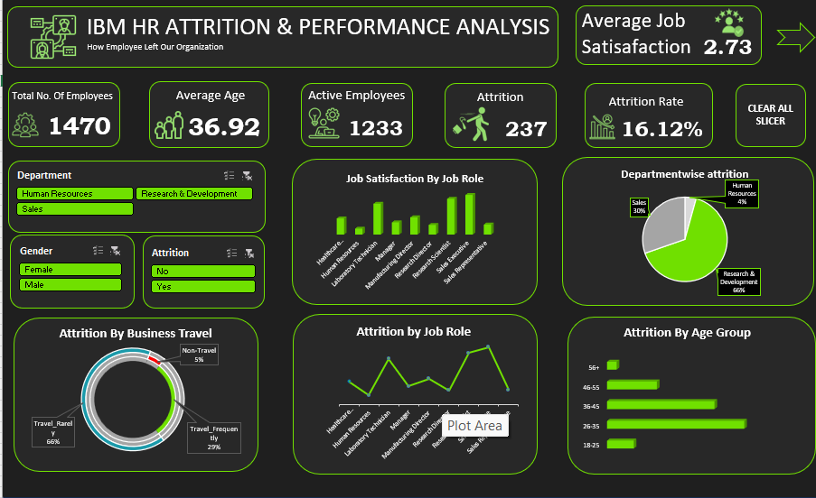

Conclusion

The HR Attrition Dashboard provides a clear understanding of the key factors influencing employee turnover. By analyzing age, department, compensation, tenure, and work-life balance, it uncovers critical patterns that drive attrition. These insights empower HR leaders to design effective retention strategies, improve employee engagement, and foster organizational stability. Ultimately, the dashboard transforms raw data into actionable intelligence for building a stronger and more resilient workforce.